# Operational Concept Description (OCD)

[**City of Los Angeles**](http://greenbay.usc.edu/csci577/fall2013/projects/team09/)

[**Applicant Resource Center**](http://greenbay.usc.edu/csci577/fall2013/projects/team09/)

**Team 09**

**Team members and roles:**

**Vaibhav Mathur, Project Manager**

**Preethi Ramesh, Feasibility Analyst**

**Arijit Dey, Requirements Engineer**

**Shreyas Devraj, Life Cycle planner**

**Gaurav Mathur, Builder**

**Divya Nalam, OCE**

**Rakesh Mathur, IIV&V**

**23rd October 2013**

# 

# Version History

|  |  |  |  |  |
| --- | --- | --- | --- | --- |
| **Date** | **Author** | **Version** | **Changes made** | **Rationale** |
| 09/26/13 | DN | 1.0 | Initial draft for CSCI 577a; Template taken from ICSM EPG course material |  |
| 10/16/13 | DN, PR | 1.1 | Added the details of the proposed system like element relationship diagrams and business workflows | Enhancements for Foundation phase. |
| 10/20/2013 | DN | 1.2 | * Added missed out stakeholders * Updated Program model, Benefits chain and System Boundary accordingly * Added Language module to the proposed new system | Update of changes suggested in ARB |
| 10/23/2013 | RM | 1.3 | Fixes in Program Model and Benefits Chain diagram |  |

# Table of Contents

# 

**1. Introduction** 6

1.1. Purpose of the OCD 6

1.2. Status of the OCD 6

**2. Shared Vision** 7

2.1. Overview of the system 7

2.2. Benefits chain diagram 8

2.3. System Boundary and Environment 9

**3. System Transformation** 10

3.1. Information on Current System 10

3.1.1. Infrastructure 10

3.1.2. Artifacts 10

3.1.3. Current Business Work-flow 10

3.2. System Objectives, Constraints and Priorities 11

3.2.1. Capability Goals 11

3.2.2. Organizational Goals 11

3.2.3. Constraints 11

3.2.4. Relation to Current System 12

3.3. Proposed New Operational Concept 12

3.3.1. Element Relationship Diagram 12

3.3.2. Business Work flows 14

3.3.2.1. Adding and deleting investigators work flow: 14

3.3.2.1. Reference process and investigator assignment work flow: 14

3.3.2.3. Business workflow for reference processing when the reference does not have email ID: 15

3.4. Organizational and Operational Implications 15

3.4.1. Organizational Transformations 15

3.4.2. Operational Transformations 15

**Table of Contents** 3

**Table of Figures** 5

**Table of Tables** 4

**Version History** 2

# Table of Tables

Table 1: The Program Model

Table 2: Capability goals table

Table 3: Relation to Current System

# 

# Table of Figures

*Figure 1: Benefits Chain Diagram*

*Figure 2: System Boundary and Environment Diagram*

*Figure 3: Activity diagram for work-flow of current system*

*Figure 4: Element relationship diagram*

*Figure 5: Basic business work flow diagram for reference processing*

*Figure 6: Business work flow for adding and deleting investigators*

### 1. Introduction

##### 1.1. Purpose of the OCD

The purpose of the OCD is to capture the vision of the success critical stakeholders of this project.

The success critical stakeholders for this project along with their roles are as follows:

* City of Los Angeles Department of Personnel Public Safety Background & Employment Services Division - owner
* Supervisors, investigating officers, administrators and supporting staff - users
* City IT staff – maintainers
* Members of Team 09 - developers

##### 1.2. Status of the OCD

The version number for this document is 1.1 and the project is currently in the Valuation phase.

Some of the open issues that have to be resolved are as follows:

* Modify the current prototype to use DB2
* Extend the prototype to store reference responses in the database and retrieve them.

### 

### 2. Shared Vision

##### 2.1. Overview of the system

**Table 1: The Program Model**

|  |
| --- |
| **Assumptions:**   * The new system will be accepted by the staff of City. |

|  |  |  |  |
| --- | --- | --- | --- |
| **Stakeholders** | **Initiatives** | **Value Propositions** | **Beneficiaries** |
| * References * Support Staff * Investigators * Managers * City IT staff * Developers | * Develop the web based system for reference processing * Provide training to the City staff to use the new system * Maintain the web based system | * Decrease time spent on requesting and processing references * Decrease number of personnel involved in processing reference letters * Decrease administrative costs * Decrease paperwork | * Applicants * Supports staff * Investigators * Managers |

|  |  |
| --- | --- |
| **Costs** | **Benefits** |
| * Time spent by client in giving inputs to development team, evaluating prototypes and training staff. * Developer time * Maintenance costs (IT staff) * Hardware Costs:  1. Web Server running Windows Operating System with IIS6 or above 2. Web Server Hosting on the World Wide Web 3. DB2 (or SQL Server) Database (Licenses plus hardware/software)” | * Decreased costs (postal charges avoided) * Decreased time in sending reference requests and receiving responses * Decreased effort for staff due to avoiding paper work and managers due to electronic monitoring of reference process * Increased efficiency of reference processing |

##### 2.2. Benefits chain diagram

**Assumptions:**

* The new system will be accepted by the staff of City

City IT staff

Provide training to the staff

Maintain the system

Manual

Work Reduced

Automatic reference processing and tracking system developed

Develop the web application

Developer

Easier tracking

Quicker responses

Easier tracking

Paperwork avoided

Quicker requests

Complete reference form online

Review investigator assignments and references online

Review reference letter online

Send reminder emails through the web application

Send reference request emails through the web application

Support staff

Investigator

Manager

Reference

**Figure 1: Benefits Chain Diagram**

##### 

##### 2.3. System Boundary and Environment

**Applications:**

* Automated Email
* Reference letter completion
* Reference letter viewing
* Investigator assignment

**Support Infrastructure:**

* ASP.net
* Visual Studio Express
* DB2
* Structured Query Language

**Figure 2: System Boundary and Environment Diagram**

**3. System Transformation**

### 3.1. Information on Current System

##### 3.1.1. Infrastructure

The City of LA, Applicant Resource Center performs background investigations of job applicants by reviewing reference letters. This is currently performed manually using postal service.

For the applicants who have been selected, the supporting staff look up the references mentioned in the application and send mails to them enclosing the confidentiality agreement and the reference letter form. These references in turn fill up the forms and send them back to the City of LA listing out other possible references for the same candidate.

Investigating officers are assigned to applicants by the Background Investigation Supervisor. This information is maintained by the Supervisor using spreadsheets.

##### 3.1.2. Artifacts

The following is a list of physical forms and letters that the current system uses:

* LA City Application Form: This includes the complete questionnaire that the applicant fills out during the application. This includes the list of references that he wish to provide.
* Confidentiality Personal Inquiry: The confidentiality agreement that has to be signed by the references
* Personal Inquiry Questionnaire Police Officer Applicant: The form to be filled up by the reference with the details about the applicant. This form also provides a provision for the reference to list out additional references for the same applicant.

##### 3.1.3. Current Business Work-flow

##### 

**Figure 3: Activity diagram for work-flow of current system**

### 3.2. System Objectives, Constraints and Priorities

##### 3.2.1. Capability Goals

**Table 2: Capability goals table**

|  |  |
| --- | --- |
| **Capability Goals** | **Priority Level** |
| **OC-1: Automatic email generation to references:** The system provides for support staff to fill in the candidate and reference information electronically so as to automatically send emails requesting reference letters. | 1 |
| **OC-2: Reference letter completion:** The systems provides for references to submit their letters online and stores them in the database | 1 |
| **OC-3: Display of reference letters:** The system is capable of displaying the completed reference letters to investigators. | 1 |
| **OC-4: References review and reminders sending:** The system allows investigators to review the references for each candidate assigned to him and send reminders to those references who have not yet responded. | 1 |
| **OC-5: Manager reviews:** The system allows managers to review the candidates assigned to each investigator and the reference status of each candidate. | 2 |
| **OC-6: Investigator assignment:** The system allows investigators to view unassigned candidates and assign the candidates to themselves. | 2 |
| **OC-7: Investigators update:** The system allows managers to add, edit or delete investigators. | 3 |
| **OC-8: Language options:** The system allows the user to choose English or Spanish | 3 |

##### 3.2.2. Organizational Goals

* + **OG1:** Improve reference responses by providing for web based reference letter submission.
  + **OG2:** Reduce labor hours and paper work for support staff by providing an electronic system for automatically sending emails for reference requests.
  + **OG3:** Eliminate postal costs in reference processing.
  + **OG4:** Reduce labor hours for managers and investigators by providing a web based application for tracking assigned candidates and reference responses.

##### 3.2.3. Constraints

**CO1:** Use of DB2

**CO2:** Use of Cold Fusion or ASP.net for development

**CO3:** Data storage on in-house LAPD server

##### 3.2.4. Relation to Current System

**Table 3: Relation to Current System**

|  |  |  |
| --- | --- | --- |
| **Capabilities** | **Current System** | **New System** |
| **Roles and Responsibilities** | 1. Support staff mails reference requests via post. 2. References manually fill up the paper form and mail it back. | 1. Support staff fills in the online form to generate emails to references. 2. Fill in the form online and submit |
| **User Interactions** | Interactions between Support staff and References through post | Interactions are electronic. |
| **Infrastructure** | Infrastructure requires long people hours and relies heavily on the postal system. | Infrastructure eliminates need for postal system and reduces the long labor hours. |
| **Stakeholder Essentials and Amenities** |  | Online reference letter submission provision. |
| **Future Capabilities** |  | 1. Support for sending cascading reference requests. 2. Integration with LDAP for authentication and authorization. |

### 3.3. Proposed New Operational Concept

##### 3.3.1. Element Relationship Diagram

##### The proposed new model consists of the following modules:

##### Authentication module: This module takes the username and password from the user and checks the authenticity of the user. Depending upon who the user is, the next interface is displayed.

##### Support staff module: This module is used to receive the inputs from the support staff, which includes details of the candidates (like first and last names, last four digits of their SSN, department applied, etc.) and the details of the corresponding references (like name and email ID). Upon submission of these details to the database, the email-IDs of the references entered in the form are sent to the ‘Email generator’ module.

##### Email generator module: This module sends out emails to references. It interacts with the ‘Support Staff’ module to send out the first set of emails requesting references for each candidate. Investigators also interact with this module to send reminders to references who have not responded.

##### Investigator module: This module has two sub-modules. The investigators interact with the ‘Unassigned Candidates UI’ module to assign candidates to themselves. This information is then updated in the database. The investigators use the ‘Reference Letter UI’ module to review the reference responses received.

##### Manager module: This module has three sub-modules:

##### The ‘Investigators listing UI’ lists all the investigators and allows managers to add or delete investigators to this list.

##### The ‘Investigators Review UI’ is used by managers to review the overall investigator-candidate assignments.

##### The ‘Reference Status UI’ is used by managers to review the status of reference letters (received/not received) of all the candidates.

##### Reference module: This module has two sub-modules:

##### The References interact with the ‘Language module’ to input their language option. This module then interacts with the database to retrieve reference form in the language specified.

##### The “Reference form UI” receives the references responses and stores it in the database.

Send reminder mails

Send reference request

Update

D

A

T

A

B

A

S

E

Input information

Support staff

Support staff UI

AUTHENTICATION

Send emails

Provide

Access

Email generator

Update assignment info

Select applicants

Unassigned Candidates UI

Investigator

Query

Review request

Reference Letters UI

USER

`

Add, delete investigator

Update

Investigator listing UI

Username & password

Manager

Query

Review request

Investigator review UI

Query

Review request

Reference Status UI

Query reference form of chosen language

Choose language

Language module

Display form Review request

Input information

Reference form UI

Reference

Update

**Figure 4: Element relationship diagram**

##### 3.3.2. Business Work flows

##### 3.3.2.1. Reference process and investigator assignment work flow:

This is the basic work flow of the system where the support staff initiates the reference process by filling in the candidate and respective reference information; and sending out the first request mails for reference filling. The reference clicks on the secure link, completes the reference form and submits. Once the investigator is intimated by the supervisor, he assigns candidates to himself and starts reviewing. If any reference requests are found to have not been responded to for a long time, the investigator can send reminder mails to that reference.

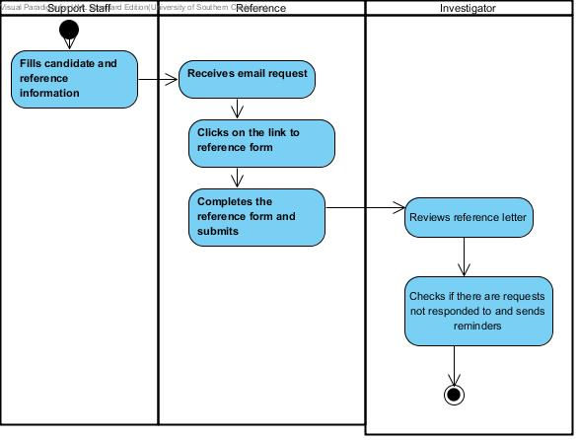

**Figure 5: Basic business work flow diagram for reference processing**

##### 3.3.2.1. Adding and deleting investigators work flow:

This is the work flow for adding and deleting investigators to the database by the supervisor/manager. After a supervisor adds an investigator to the database, the investigator will be allowed to assign candidates to himself and start reviewing their references. Once an investigator is deleted from the database, all the candidates assigned to him will be put into the pool of unassigned candidates.

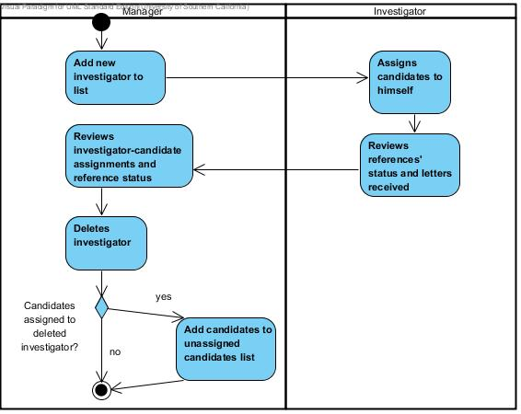

**Figure 6: Business work flow for adding and deleting investigators**

##### 3.3.2.3. Business workflow for reference processing when the reference does not have email ID:

##### When the references do not have email-IDs, the current process which depends on the postal system is followed. (Figure 3)

### 3.4. Organizational and Operational Implications

##### 3.4.1. Organizational Transformations

* + Need a new maintainer for the new system since it uses ASP.net and C#
  + The paper based work related to reference requests and responses processing is reduced due to the web based system.

##### 3.4.2. Operational Transformations

* + Investigators need to assign candidates to themselves using the new application on intimation from the Supervisor.
  + Investigators will be able to choose unassigned candidates' application for processing even without assignment by the Supervisor.